Net 1060 Introduction to Networks Lab: # 17.7.7

Name:

Follow the instructions down below for the lab itself. For this lab, all answers need to be in blue font. For the questions right below, answer in complete sentences. Ensure you paste the screen shot of your score page at the bottom of the document. Even if this does not let you see your grade, still take a screen shot of the score page showing congratulations “your name” you have completed the exercise is pasted at the bottom of this document. You will then need to upload both this word document and your packet tracer file to the assignments link within Netacad. Let the instructor know if you have any questions.

Lab Analysis Report

1. Using complete sentences summarize work you completed during the lab.
In this lab I troubleshooted a network and fixed the connectivity issues. I used the ping and tracert tools to test the connectivity. I also reconfigured the pc, router, and switch until the issues were resolved.

2. Using complete sentences describe what you learned from the lab. Hint; look at the lab objectives listed at the top of the lab section.
In this lab I learned how to troubleshoot a network and resolve the issue. I learned more about how to apply my skills to real world scenarios.

Problems Encountered

1. Using complete sentences describe any problem(s) experienced during lab.
After reconfiguring the Ip addresses I couldn’t figure out why the network was still slow.

2. Using complete sentences describe how you solved your problem(s).
I solved this problem by going to the internet and learning the last thing I was missing.

3. Using complete sentences explain if you needed any assistance with the lab; then list what you learned from that assistance.
I got assistance from the internet and learned that you can control the speed of the sending and receiving of an interface. I learned how to check the speed and how to change it.

Packet Tracer - Troubleshoot Connectivity Issues - Physical Mode

Topology
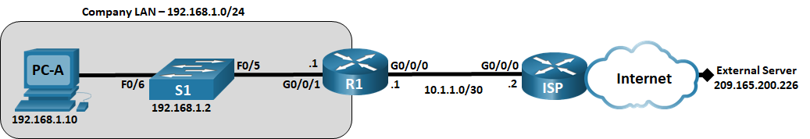

Addressing Table
Device | Interface | IP Address | Subnet Mask | Default Gateway
R1 | G0/0/0/1 | 192.168.1.1 | 255.255.255.0 | N/A
R1 | G0/0/0 | 10.1.1.1 | 255.255.255.252 | N/A
ISP | G0/0/0 | 10.1.1.2 | 255.255.255.252 | N/A
ISP | Lo0 | 209.165.200.226 | 255.255.255.255 | N/A
S1 | VLAN 1 | 192.168.1.2 | 255.255.255.0 | 192.168.1.1
PC-A | NIC | 192.168.1.10 | 255.255.255.0 | 192.168.1.1
Blank Line - no additional information

Objectives
Part 1: Identify the Problem
Part 2: Implement Network Changes
Part 3: Verify Full Functionality
Part 4: Document Findings and Configuration Changes

Background / Scenario
In this Packet Tracer Physical Mode (PTPM) activity, the company that you work for is experiencing problems with their LAN. You have been asked to troubleshoot and resolve the network issues. In Part 1, you will connect to devices on the LAN and use troubleshooting tools to identify the network issues, establish a theory of probable cause, and test that theory. In Part 2, you will establish a plan of action to resolve and implement a solution. In Part 3, you will verify that full functionality has been restored. Part 4 provides space for you to document your troubleshooting findings along with the configuration changes that you made to the LAN devices.

Instructions

Identify the Problem
The only available information about the network problem is that the users are experiencing slow response times and that they are not able to reach an external device on the internet at IP address 209.165.200.226. To determine probable cause(s) for these network issues, you will need to utilize network commands and tools on the LAN equipment.
Note: The username admin01 with a password of cisco12345 will be required to log on to the network equipment.

Troubleshoot the network.
Use the tools available to you to troubleshoot the network, keeping in mind that the requirement is to restore connectivity to the external server and the eliminate slow response times.

Document the probable causes.
List the probable causes for the network problems that employees are experiencing.
The probable cause for the network problems is a misconfiguration of the ports and ip addresses.Type your answer here.

Implement Network Changes
You have communicated the problems that you discovered in Part 1 to your supervisor. She has approved these changes and has requested that you implement them.

Verify Full Functionality
Verify that full functionality has been restored. PC-A, S1, and R1 should be able to reach the external server, and ping replies from PC-A to the external server should exhibit no significant variation in response times.

Document Findings and Configuration Changes
Use the space provided below to document the issues found during your troubleshooting and the configurations changes made to resolve those issues.
I found that the default gateway was not set properly for the PC and the switch interface. I tested this by using the ping command and found out that pinging the switch from the pc didn’t work. After this I tried pinging the outside server and was reaching it but still getting timeouts and missing replies. I configured all the ports and interfaces on the switch and router to have the correct ip address, subnet mask, and default gateway. Then I tried again and was still getting slow response times. I went to the switch and shutdown all the ports that weren’t being used then checked the speed of the ports that were being used. I changed the speed to 100 and did the same thing on the router. I tested it again and the problems were gone.
Type your answers here.

Reflection Question
This Packet Tracer Lab Companion had you troubleshoot all devices before making any changes. Is there another way to apply the troubleshooting methodology? Another way to troubleshoot would be to troubleshoot each individual device until it is fully working before moving on to the next device.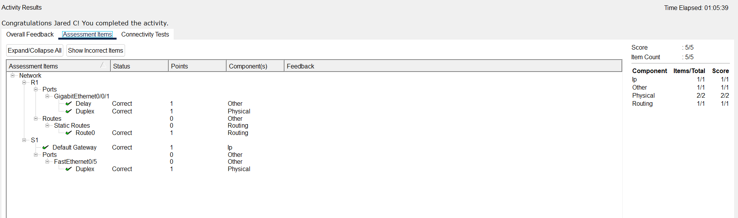

Type your answers here.
End of document
End of document

